Poker ride sunday, July 27, 2014  Registration 9:30 am – 10:45 am with last group/rider leaving at 11:00 am  Poker Ride is to raise money to assist Lt Jeff Nash, Caln Police Department in his fight against cancer.  Donation of $20.00/rider and $10/passenger is requested with kids under 12 free. The poker ride can be completed by motorcycle or car. Top 3 poker hands will be awarded prizes at VFW Post at the end of ride. T-shirts will be for sale and we ask that the pre-registration form below be completed and mailed in so that we will have an idea on the number of participants. You can also register at the K-Mart on the day of the ride.  ************* CUT HERE AND MAIL BOTTOM PORTION *************  [Event Title, Up to Two Lines]  [Event Description Heading]  [To replace any tip text with your own, just click it and start typing. To replace the photo or logo with your own, right-click it and then click Change Picture. To try out different looks for this flyer, on the Design tab, check out the Themes, Colors, and Fonts galleries.]  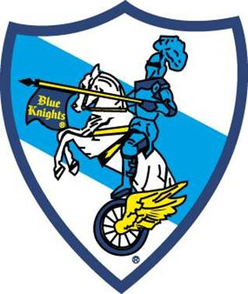  Rider ______________________________  Passenger __________________________  Address ____________________________  Phone # ____________________________  Email ______________________________  Number attending ____________________ |  | The poker ride starts at the K-Mart parking lot (3205 Lincoln Highway, Thorndale, PA 19372) where your first poker card is drawn.  Self-Guided ride with 4 stops along the route to draw poker cards and the chance to buy extra cards to better your poker hand at the last stop.  Poker ride ends at VFW Post 845 (4601 W Lincoln Highway, Downingtown PA 19335) where there will be food, door prizes, poker hand prizes and a 50/50 drawing!  Lunch will be served at noon.  Make check out to:  Blue Knights PA XIII  Mail check and registration to Caln Township, c/o Lori Daniels, 253 Municipal Drive, Thorndale, PA 19372  For questions, contact: Lori Daniels 610-383-1821, ldaniels@calntownship.org or Pam McClaren 610-637-5881, Pamelaabk@aol.com

